Tree

What is a Tree?
# Source: AI Source: Provided by: [Data Path: Persons Table -> ID Column: 1, Name_En Column: Motasem Essam] -> From: [Chatgpt (GPT‑5 Mini)] on [12/10/2025]
- A Tree is a hierarchical data structure consisting of nodes connected by edges.
- It has a root node and zero or more child nodes.
- Nodes with no children are called leaf nodes.
- Trees are widely used in databases, file systems, expression parsing, and hierarchical relationships.

Key Characteristics
# Source: AI Source: Provided by: [Data Path: Persons Table -> ID Column: 1, Name_En Column: Motasem Essam] -> From: [Chatgpt (GPT‑5 Mini)] on [12/10/2025]
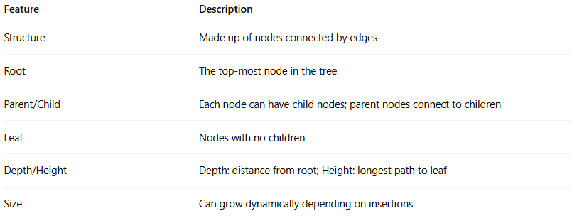
Feature | Description
Structure | Made up of nodes connected by edges
Root | The top-most node in the tree
Parent/Child | Each node can have child nodes; parent nodes connect to children
Leaf | Nodes with no children
Depth/Height | Depth: distance from root; Height: longest path to leaf
Size | Can grow dynamically depending on insertions

Types of Trees
# Source: AI Source: Provided by: [Data Path: Persons Table -> ID Column: 1, Name_En Column: Motasem Essam] -> From: [Chatgpt (GPT‑5 Mini)] on [12/10/2025]
- Binary Tree
  - Each node has at most two children (left and right).
  - Example:
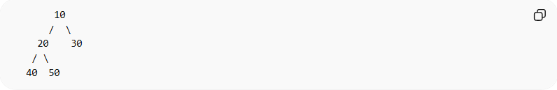
10
/ \
20 30
/ \
40 50
- Binary Search Tree (BST)
  - Binary tree with ordered nodes: left child < parent < right child.
  - Allows fast searching, insertion, and deletion.
  - Example:
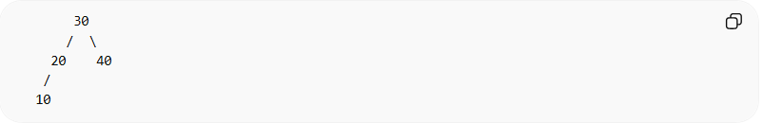
30
/ \
20 40
/
10
- AVL Tree (Self-Balancing BST)
  - A BST that maintains balance after insertions and deletions.
  - Height difference between left and right subtrees ≤ 1.
- Full Binary Tree
  - Every node has 0 or 2 children.
- Complete Binary Tree
  - All levels are completely filled except possibly the last, which is filled from left to right.
- Perfect Binary Tree
  - All internal nodes have 2 children, and all leaf nodes are at the same level.
- General Tree
  - Nodes can have any number of children.

Example of a Binary Tree
# Source: AI Source: Provided by: [Data Path: Persons Table -> ID Column: 1, Name_En Column: Motasem Essam] -> From: [Chatgpt (GPT‑5 Mini)] on [12/10/2025]
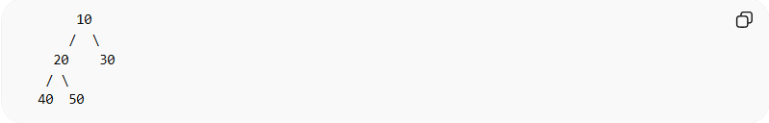
10
/ \
20 30
/ \
40 50
- Root: 10
- Leaf nodes: 40, 50, 30

Example in C (Binary Tree Node)
# Source: AI Source: Provided by: [Data Path: Persons Table -> ID Column: 1, Name_En Column: Motasem Essam] -> From: [Chatgpt (GPT‑5 Mini)] on [12/10/2025]
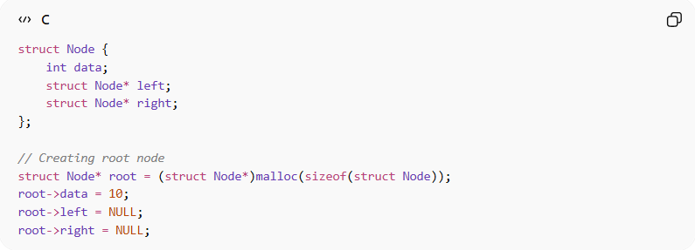
struct Node {
int data;
struct Node* left;
struct Node* right;
};

// Creating root node
struct Node* root = (struct Node*)malloc(sizeof(struct Node));
root->data = 10;
root->left = NULL;
root->right = NULL;

Common Operations on Trees

1. Insertion (Adding a Node)
# Source: AI Source: Provided by: [Data Path: Persons Table -> ID Column: 1, Name_En Column: Motasem Essam] -> From: [Chatgpt (GPT‑5 Mini)] on [12/10/2025]
Definition:
- Insertion adds a new node to the tree at the appropriate position (depends on tree type).
Example (BST Insertion):
Insert 25 into BST:
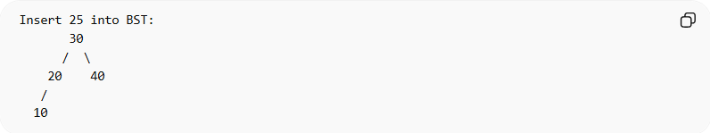
30
/ \
20 40
/
10
- New tree after insertion:
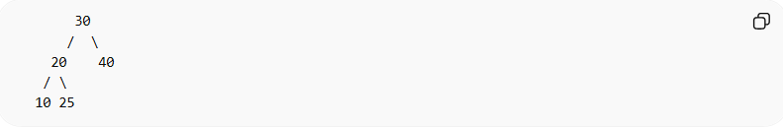
30
/ \
20 40
/ \
10 25
Insertion Time Complexity:
- Time Complexity: O(h)
- Reason: Must traverse from root to the correct position; h = height of tree.

2. Deletion (Removing a Node)
# Source: AI Source: Provided by: [Data Path: Persons Table -> ID Column: 1, Name_En Column: Motasem Essam] -> From: [Chatgpt (GPT‑5 Mini)] on [12/10/2025]
Definition:
- Removes a node from the tree and adjusts the tree to maintain its properties.
Example (BST Deletion of 20):
Before deletion:
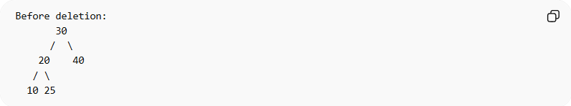
30
/ \
20 40
/ \
10 25
- After deletion (replace with inorder successor):
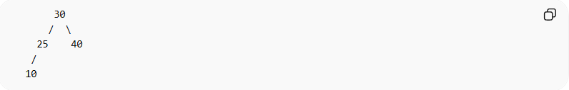
30
/ \
25 40
/
10
Deletion Time Complexity:
- Time Complexity: O(h)
- Reason: Must traverse to node and possibly adjust children to maintain tree structure.

3. Traversal (Visiting All Nodes)
# Source: AI Source: Provided by: [Data Path: Persons Table -> ID Column: 1, Name_En Column: Motasem Essam] -> From: [Chatgpt (GPT‑5 Mini)] on [12/10/2025]
Definition:
- Traversal means visiting all nodes in a tree in a specific order.
- It is often used to:
• Print node values
• Evaluate expressions
• Search or process nodes

Types of Traversal
1. Inorder Traversal (Left, Root, Right)
Definition:
- Visit the left subtree, then the root, then the right subtree.
- Commonly used in binary search trees to get nodes in sorted order.
Example (BST):
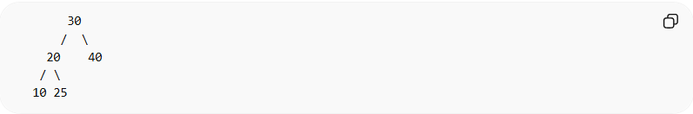
30
/ \
20 40
/ \
10 25
- Inorder Traversal sequence: 10 20 25 30 40
Example in C (Recursive):
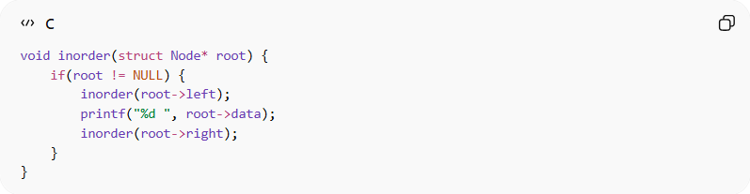
void inorder(struct Node* root) {
if(root != NULL) {
inorder(root->left);
printf("%d ", root->data);
inorder(root->right);
}
}
Time Complexity:
- Time Complexity: O(n)
- Reason: Each node is visited once.

2. Preorder Traversal (Root, Left, Right)
Definition:
- Visit the root first, then the left subtree, then the right subtree.
- Useful for copying a tree or creating prefix expression.
Example (BST above):
- Preorder Traversal sequence: 30 20 10 25 40
Example in C (Recursive):
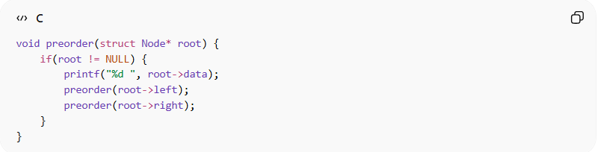
void preorder(struct Node* root) {
if(root != NULL) {
printf("%d ", root->data);
preorder(root->left);
preorder(root->right);
}
}
Time Complexity:
- Time Complexity: O(n)
- Reason: Each node is visited once.

3. Postorder Traversal (Left, Right, Root)
Definition:
- Visit the left subtree, then the right subtree, then the root.
- Useful for deleting a tree or evaluating postfix expression.
Example (BST above):
- Postorder Traversal sequence: 10 25 20 40 30
Example in C (Recursive):
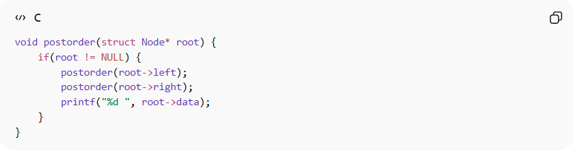
void postorder(struct Node* root) {
if(root != NULL) {
postorder(root->left);
postorder(root->right);
printf("%d ", root->data);
}
}
Time Complexity:
- Time Complexity: O(n)
- Reason: Each node is visited once.

4. Level Order Traversal (Breadth-First)
Definition:
- Visit nodes level by level, starting from the root.
- Useful for printing hierarchical structures.
Example (BST above):
- Level Order Traversal sequence: 30 20 40 10 25
Example in C (Using Queue):
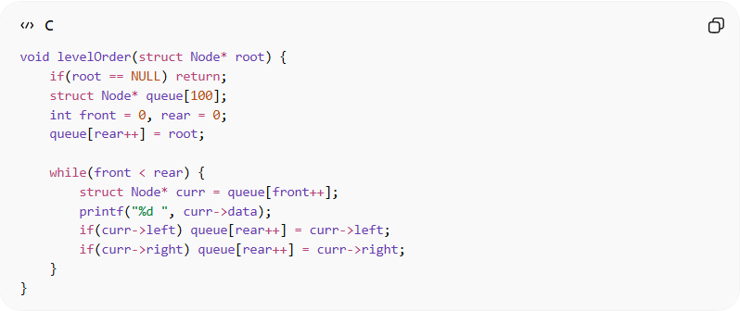
void levelOrder(struct Node* root) {
if(root == NULL) return;
struct Node* queue[100];
int front = 0, rear = 0;
queue[rear++] = root;

while(front < rear) {
struct Node* curr = queue[front++];
printf("%d ", curr->data);
if(curr->left) queue[rear++] = curr->left;
if(curr->right) queue[rear++] = curr->right;
}
}
Time Complexity:
- Time Complexity: O(n)
- Reason: Every node is visited once.

4. Searching (Finding a Node)
# Source: AI Source: Provided by: [Data Path: Persons Table -> ID Column: 1, Name_En Column: Motasem Essam] -> From: [Chatgpt (GPT‑5 Mini)] on [12/10/2025]
Definition:
- Searching means finding a node with a specific value.
Example (Searching 25 in BST):
- Start at root 30 → move left to 20 → move right to 25 → found.
Search Time Complexity:
- Time Complexity: O(h)
- Reason: Must traverse from root following tree property until the target is found; h = height of tree.

Summary of Tree Operations
# Source: AI Source: Provided by: [Data Path: Persons Table -> ID Column: 1, Name_En Column: Motasem Essam] -> From: [Chatgpt (GPT‑5 Mini)] on [12/10/2025]
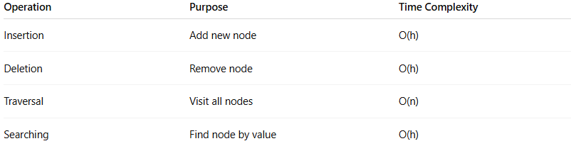
Operation | Purpose | Time Complexity
Insertion | Add new node | O(h)
Deletion | Remove node | O(h)
Traversal | Visit all nodes | O(n)
Searching | Find node by value | O(h)

Real-World Examples
# Source: AI Source: Provided by: [Data Path: Persons Table -> ID Column: 1, Name_En Column: Motasem Essam] -> From: [Chatgpt (GPT‑5 Mini)] on [12/10/2025]
- File system directory structure
- Expression trees in compilers
- Hierarchical organization charts
- Decision trees in AI

Advantages
# Source: AI Source: Provided by: [Data Path: Persons Table -> ID Column: 1, Name_En Column: Motasem Essam] -> From: [Chatgpt (GPT‑5 Mini)] on [12/10/2025]
- Efficient hierarchical representation
- Dynamic size
- Faster search in BST compared to unsorted lists

Disadvantages
# Source: AI Source: Provided by: [Data Path: Persons Table -> ID Column: 1, Name_En Column: Motasem Essam] -> From: [Chatgpt (GPT‑5 Mini)] on [12/10/2025]
- Complex implementation
- Traversals can be costly for unbalanced trees
- Extra memory for pointers

